Attendees: Steve Henion, Tim Stickney, Mark Hadley, Paul Tooley, Mike Fraticelli, Wes Jackson, Derek Cass, Bill Sulzen

Minutes

Mike opened the meeting with a prayer.

Four main areas of discussion ensued: organizational structure, finances, uniform, calendar.

Organizational Structure

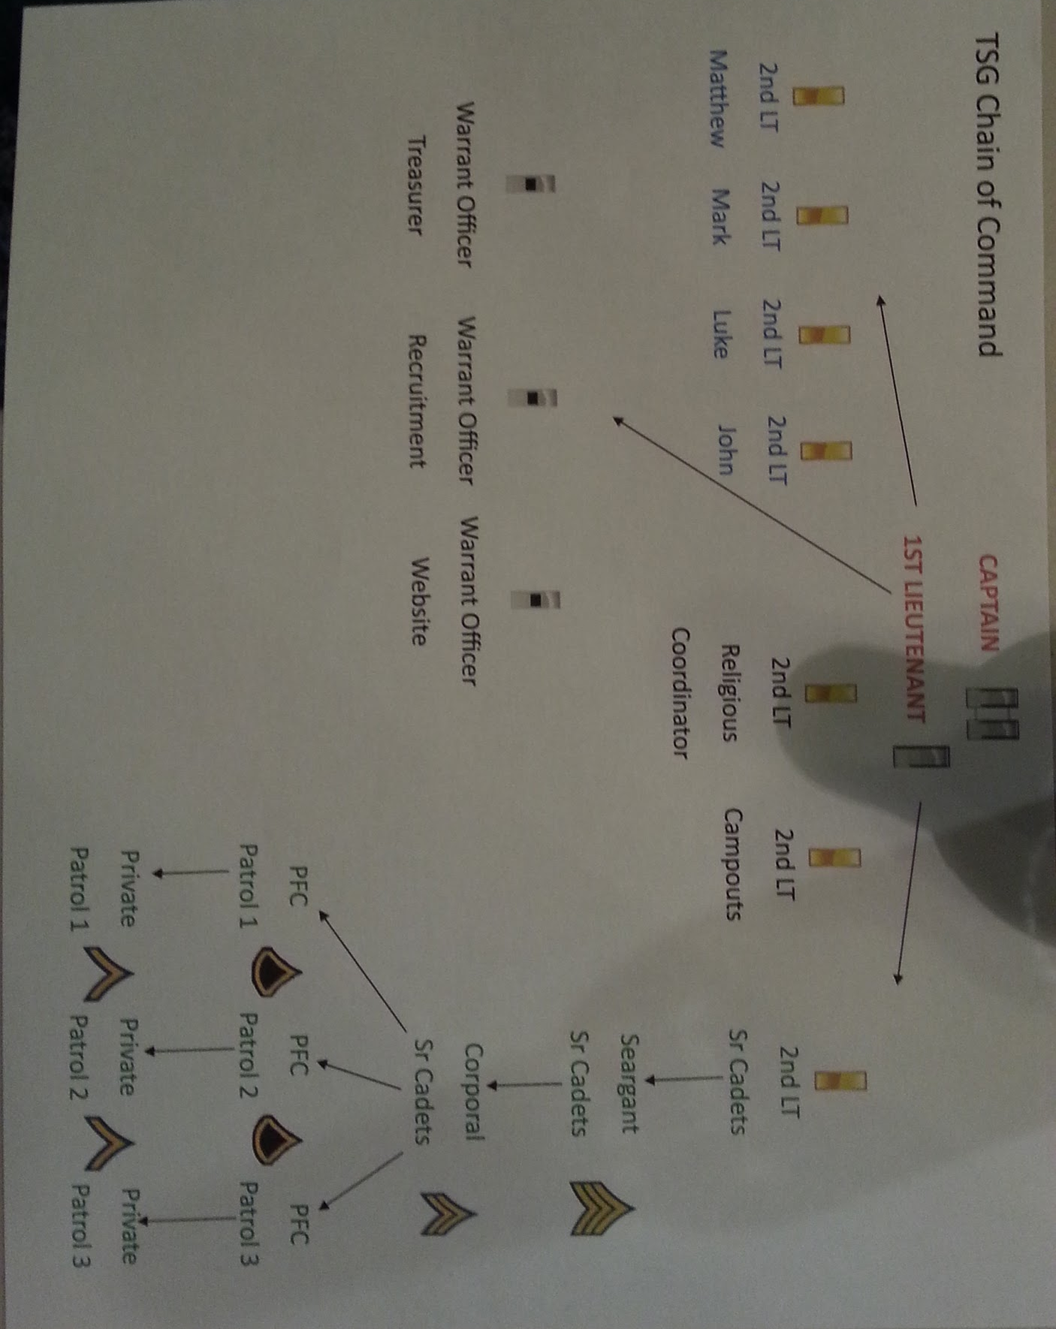

Officers roles - to be filled by Dads (as described in 2015 Officer’s Manual).
Cadets fill other roles and are voted on annually.

Roles filled at meeting:
Captain - Steve
1st Lt - Marc
Campouts - Bill
Treasurer - Tim
Website - Derek
Recruitment - Doug
Religious Coordinator - Tim
2nd Lt Sr Cadets - Mike
2nd Lt Junior Cadets (Matthew) - Jan Wetherell
2nd Lt Junior Cadets (Mark) - Mark H
2nd Lt Junior Cadets (Luke) - Wes
2nd Lt Junior Cadets (John) - Paul

Monthly meetings will be moved to St. Joseph’s

St. Joseph’s wants all dad’s to take safe environment training and obtain the background check.
We need roster of all dads, kids contact information for diocese requirements.
AI: Bill to collect roster of dads and kids. Name, address phone number.

Finances

National wants us to be setup as an LLC.
AI: Tim to investigate LLC

We are covered by national insurance. For meetings, we are covered by St. Joseph’s insurance. We should establish our own liability insurance for campouts.
The exact benefits of each are being determined by Steve.

Dues:
National: $80 per troop, $30 per kid, $30 per dad.
Local (tentative): $20 per kid, $20 per dad

AI: the treasurer will appoint a fundraising officer

Uniform

Per the Uniform Guidelines we must design 2 local patches: a troop badge and a senior patrol badge. Steve will send out patch proposals. Class A uniforms will be purchased from national. Kids and officer dads will need uniforms. Long sleeve $35 (kids), adult $39. Pants $35/$39. Shorts $29/$29. Class B T shirts $12.75.

Total uniform cost including patches: TBD
Class B uniform for our troop: national T shirt, khaki or olive shorts.

Calendar

Troop meetings will continue to be held the second Tuesday of every month (at St. Joseph’s).

Campouts/outings - 4-6 per year (not in July, August, December, January). Hikes and other outings may be substituted for campouts. September campout will include patch ceremony.

Other

National suggestions: obtain a first aid bag, 1-2 dads obtain CPR training
AI: Paul to call Red Cross

Dragon Slayer requirements must be met by September for all seniors.
Juniors must have met all requirements for rank they are exiting. All dads need to be working with their sons over the summer to ensure they meet their requirements (as described in 2015 Officer’s Manual in the Requirements section).

There will be no July meeting.

The August meeting will be an officer’s-only meeting.

Tim closed the meeting with a prayer.

